Considering the tape symbol as a tuple - Multiple tracks Turing Machine

1. Can a multi-track Turing machine can be converted to single track Turing machine (**TRUE** /FALSE)?
2. Are Multi-tape and multi-track Turing machine same? (**TRUE** /FALSE)
3. The value of m if Turing machine is defined using m-tuple
4. 6
5. **7**
6. 8
7. 5
8. In multi tape Turing machine, the head of the first tape is at the end of the input
9. **Left**
10. Right
11. Middle
12. Corner
13. S1: There exists a deterministic Turing machine corresponding to each non-deterministic Turing Machine

S2: There exists a single tape Turing machine corresponding to each multi-tape Turing machine.

Which of the following is correct?

1. **Both S1 and S2 are true**
2. Neither S1 and S2 are true
3. Only S1 is true
4. Only S2 is true
5. The below transition diagram accept the _______string

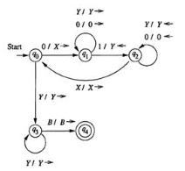

1. 0n1n
2. 0n0n1n
3. 0n0n
4. 1n1n

**Scenario based- Considering the state as a tuple**

1. An equity trader invested in two stocks with same quantities where the quantity is represented as n. He then realized that during market crash, whenever he invested in a third stock with the same quantity as that of his first stock, he could make a reasonable profit and so he invested in a third stock of quantity n. Help the investor with a diagrammatic representation of a suitable turing machine that would accept only if the investments would yield a reasonable profit by satisfying the above mentioned criteria.

Sol: Turing Machine for L ={ anbncn}

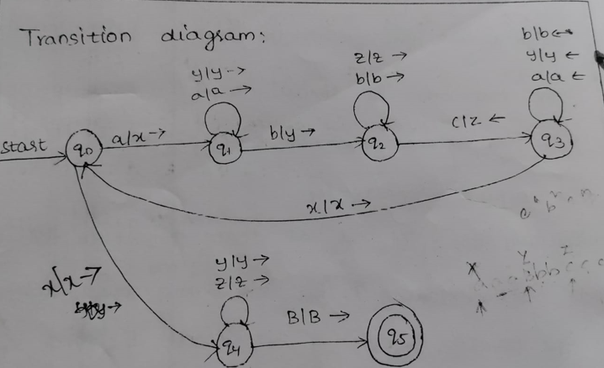

**Descriptive Question**

1. Describe the following Turing machine and their working. Are they more powerful than the Basic Turing Machine?

∙ Multi-tape (Multiple Track) Turing Machine

∙ Multi-Dimensional Turing Machine

∙ Two-Way infinite tape TM

**Considering the tape symbol as a tuple is equivalent to multi track TM**

1. Construct a TM to accept {0n1n / n>=1} using Multi track TM concept

Sol: We explicitly think of the tape as if it was composed of tracks.

